Pre Annual Health Check
Questionnaire for L.D. Patients

Please fill this book in and bring it back (or email it) to your GP surgery

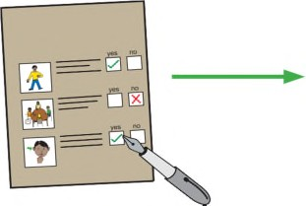
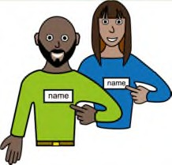 | Name ……………………  I prefer ………………….. |  | Date of birth:  …………………….
Who supports you? ………………………………………

……………………………………………………………………..

……………………………………………………………………..
Address: ………………………………………………………….

……………………………………………………………………..
…………………………………………………………………….. Telephone ………………………………………………………..
 | Email: ………………………………………………………………

Consent for Summary Care Record and additional information
1.  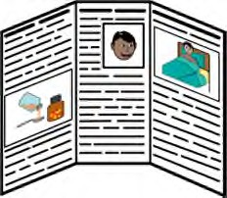 | Your Doctor will have your basic summary care record.  It has information about your health, the medications which you take and any medications which might make you ill (allergic reaction)  A doctor or nurse who doesn’t know you very well, might ask to look at your Summary Care Record, this gives them the right information to care for you.
2. | Only people like a doctor or nurse who are treating you can see your summary care record.  The Doctor can add extra information to your record with things like a history of your health problems, operations, or an illness you’ve had. It can include information about who supports you and what help or type of information you might need at appointments.  The extra information can help doctors and nurses, no matter where you are treated, look after you and help keep you well.
3. | If you would like extra information adding to your summary care record about your health and what support you need let your Doctor know.  If you don’t want your information on your Summary Care record you can ask your doctor to remove it
https://digital.nhs.uk/binaries/content/assets/legacy/pdf/p/6/scr_ai_easy_read_patient_leaflet.pdf
Do you consent to sharing information |  | Yes | No
1. Consent for electronic record sharing?
2. Consent for summary care record with additional information?
3. Consent to share data with another professional? (specified third party)

Reasonable adjustments – Care Plan
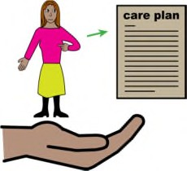 | A reasonable adjustment is a small change your Doctor can make, to make your Annual Health Check easier for you.  Below are examples of reasonable adjustments or you can get help to write down what you need in the blank section. You can ask for these reasonable adjustments to be available for you at your annual health check.
Reasonable Adjustment | How you can help me | Yes | No | Comments
 | Please add a note to my front screen that I have a learning disability
 | Please add a note to my front screen that I need a double appointment.
 | I need information in easy read
I need information in
another language – if so what language?
 | I need my carers to arrange appointments for me and to be given results of my tests etc. over the phone.
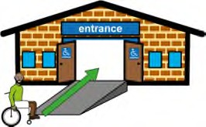 | I use a wheelchair and will need a hoist if I need a physical examination. I may need a home visit in this instance.
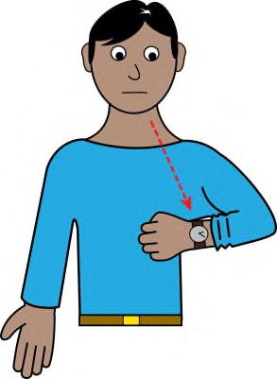 | I find it difficult to wait in the doctors for my appointment, as it may make me anxious.  I may need to wait outside until you are ready to see me.

I may need to visit the surgery before my appointment to feel comfortable in the
environment.
I need time to process
information and answer questions.
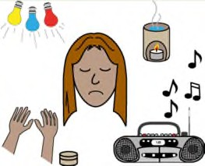 | Bright lights or loud noises may affect me.
 | My carer will support you to understand my needs.
Other reasonable adjustments?
Flu
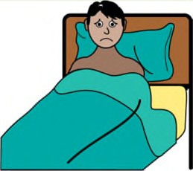 |  | Yes | No | Comments
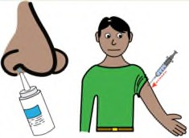 | Have you had your nasal spray or flu vaccine injection?
https://www.ndti.org.uk/uploads/files/Flu_Injection_resource.pdf

Mobility
 |  | Yes | No | Comments
Stiffness or difficulty moving
Slowing of movements
Pain when moving
Falling or tripping
Changes in posture/mobility
Mobility equipment used
Swelling or redness in
limbs/skin
Health Screening - Women
 |  | Yes | No | Comments
25 + | Have you had a smear test?
https://www.jostrust.org.uk/sites/default/files/isl116_18_er_smear_tests_final_low_res.pdf
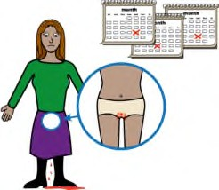 | Change in periods e.g. heavy bleeding in between periods, painful periods, Vaginal discharge
If there is a problem then please bring your menstrual chart with you if you have one.
If you are over 50 have you had a mammogram?
https://assets.publishing.service.gov.uk/government/uploads/system/uploads/attachment_data/file/765594/Easy_guide_to_breast_screening.pdf

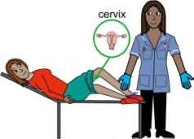

Health Screening - Men
 |  |  | Yes | No | Comments
65 + |  | Have you had your Abdominal Aortic Aneurysm or AAA Screening?
https://assets.publishing.service.gov.uk/government/uploads/system/uploads/attachment_data/file/465583/AAA_easy_read_invitation_leaflet_final.pdf
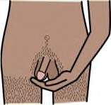 |  | Do you check your own testicles / balls
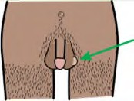 |  | Have you felt/noticed any changes to your testicles/balls?
Sexual Health
 |  |  | Yes | No | Comments
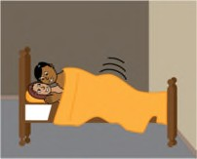 |  | Are you sexually active?
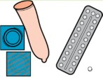 |  | Do you use anything to stop you getting pregnant or sexually transmitted infections
 | Weight
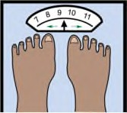 |  |  | Yes | No | Comments
Has your weight changed?
If there is a problem then please bring your weight chart if you have one.
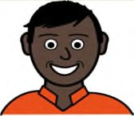
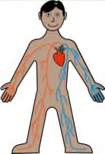

Dentist
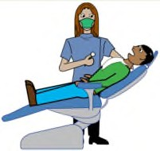 | Yes | No | Comments
Do you have a dentist? When was your last visit?
Do your teeth hurt?
Do your gums bleed?
Do you have a swelling or a lump?
Do you have difficulty eating?
Eyes
 | Yes | No | Comments
When did you last have your eyes tested
Do you have any eyesight problems or wear glasses
Hearing
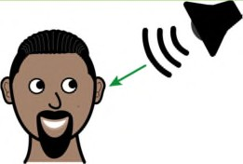 | Yes | No | Comments
Have you noticed any problems or changes to your
hearing?
Have you visited a hearing clinic (audiologist)?

Breathing
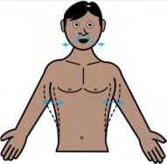 | Yes | No | Comments
Coughing that won’t go away (more than 3 weeks)
Chest infection
Coughing up blood
Unusual coloured spit
Wheeze
Hay fever, allergies, asthma or chronic obstructive pulmonary disease
Breathlessness
Do you smoke?
Eating and Drinking
 | Yes | No | Comments
Indigestion – tummy ache when you eat
Food allergies/intolerances
Being sick
Do you drink alcohol
Do you eat inedible food?
Difficulty swallowing
Coughing when eating or drinking

Bowels
 | Yes | No | Comments
Constipation – hard poo or can’t go to the toilet
Diarrhoea– watery poo and going too much
Bleeding from your bottom
Difficulty getting to the toilet on time
Changes in bowel pattern
Fatigue
Are you aged 60-74? Have you received your bowel screening kit?
https://assets.publishing.service.gov.uk/government/uploads/system/uploads/attachment_data/file/598296/easy_guide_bowel_cancer_screening.pdf
Urine
 | Yes | No | Comments
Pain when you wee?
Urine infection
Wee more often?
Do you find it difficult to start weeing?
Does your wee start and stop when you are weeing?
Blood in your wee
Difficulty in getting to the toilet in time?

Breasts
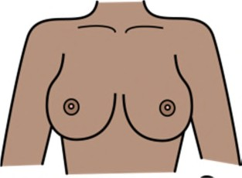 | Yes | No | Comments
Any lumps in breasts or armpits?
Any liquid from your nipple?
Any changes in the shape of your breasts?
Any changes to the skin on your breasts?
Any changes to shape of your nipples?
Do you have a change in colour to your breasts or nipples?
Do you get tired more easily?
https://assets.publishing.service.gov.uk/government/uploads/system/uploads/attachment_data/file/765594/Easy_guide_to_breast_screening.pdf
Menopausal symptoms
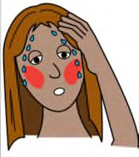 | Yes | No | Comments
Do you feel tired?
Do you have mood swings?
Do you feel sad?
Do you feel irritable?
Do you have hot flushes?

Brain
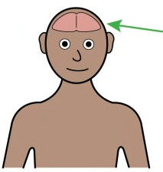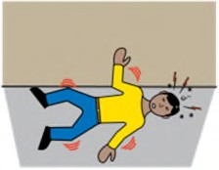 | Yes | No | Comments
Do you have epilepsy?
How many seizures per month?
Any changes to seizure?
Under the care of an epilepsy specialist(neurologist)
When did you last see them?
Triggers for Epilepsy e.g. lights, TV, tired , temperature, infections
Do you take your epilepsy medication regularly & as prescribed?
Do you have any side effects i.e. dizzy, sick, vision, irritable?
Have you had any of the following: | Yes | No | Comments
Stroke
Fainting
Blackouts
Pins and needles
Arm or leg weakness

Heart
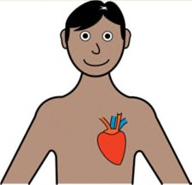 |  | Yes | No | Comments
Difficult or labored breathing during the day and at night
Chest pain when exercising
Palpitations – feeling your heart beat
Any swelling to the ankles, hands or body ect?
 | Diabetes
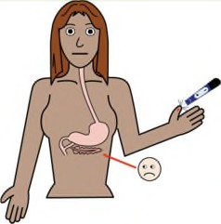 |  | Yes | No | Comments
Do you test your blood sugar regularly?
Have you been for your diabetic eye screening?
Please bring your blood sugar charts if you have them
Pain
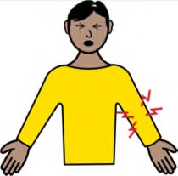 |  | Yes | No | Comments
Do you have any pain which has lasted more than 12 weeks?
Does your pain relief medicine help to stop or reduce the pain?

 | Skin
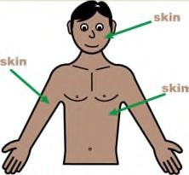 |  | Yes | No | Comments
Dry or Itchy Skin
Prescribed Skin Cream
Warts
Cold Sores
Sores or open wounds
Pressure area concerns
 | Mental Health
 |  | Yes | No | Comments
Any Worries about your Memory or confusion
Are you low, sad or unhappy?
Are you worried, frightened or anxious?
Do you feel like crying?
Have you injured yourself since your last review?
Do you feel like you can’t cope or look after yourself?
Do you feel irritable, aggressive or violent?
Have you thought about harming yourself or actually harmed yourself?
Do you hear voices or see things?
Have you spoken to someone to about how you feel?

Feet
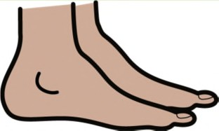 |  | Yes | No | Comments
Have you been to a podiatrist (foot specialist)? When did you last go?
If no, who cuts your nails?
Do you have any pain in your feet?
Medication Review
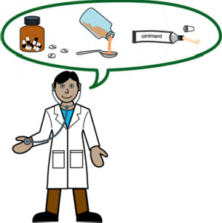 | Your Doctor will talk to you about your medication and look at whether your medication is right for you.  People with a learning disability are sometimes given medication they don’t need; your doctor will talk to you if he needs to change yours.  For more information go to:  https://www.vodg.org.uk/wp-content/uploads/2017-VODG-Preparing-to-visit-a-doctor-to-talk-about-psychotropic-medication.pdf
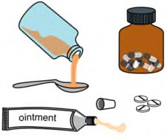 | How do you take your medication?
 | Can you swallow a tablet?
 | Do you need liquid medication?
 | Do you have any problems with taking your medication?
 | Are you worried about the effect the medication is having on you?

Hospital Passport
 |  |  | Yes | No | Comments
Do you have a hospital Passport? This helps hospital staff understand how to help you
Palliative Care
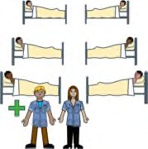 |  |  | Yes | No | Comments
Are you receiving support from palliative care services like a hospice or Marie Curie Nurse?
End of Life Gold Standard Framework
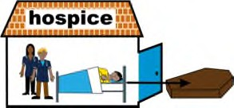 |  |  | Yes | No | Comments
DNAR or Respect Document, any concerns or questions about these documents?
Housing
Who do you live with?

Do you have carers? How often?

What do they help you with?

Bring a helper
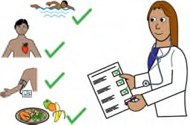 |  | You can ask questions at your health check.  You can bring someone with you who can help you in the appointment.
Do you have any questions?
Thank you for completing this form.

Please bring it with you to the health check appointment

Dr Zafar & Partners
Rillwood Medical Centre
Tonmead Road
Lumbertubs
Northampton
Northamptonshire
NN3 8HZ

Email: rillwood.k83020@nhs.net

Website: https://www.rillwoodmedicalcentre.nhs.uk/

NOTES:

